Web-Integrated Movie Recommendation Engine

|  |  |  |
| --- | --- | --- |
| **R. Bhuvaneswari**  Department of Computer Science and Engineering,  Rajalakshmi engineering College,  Chennai, India [bhuvanacheran@gmail.com](mailto:bhuvanacheran@gmail.com) | **Nithish N**  Department of Computer Science and Engineering,  Rajalakshmi Engineering College,  Chennai, India [chennainithish@gmail.com](mailto:chennainithish@gmail.com) | **Omesh Balamurugan** Department of Computer Science and Engineering,  Rajalakshmi Engineering College,  Chennai, India [omeshb2021@gmail.com](mailto:omeshb2021@gmail.com) |

|  |  |
| --- | --- |
| ***Abstract This project focuses on the development of a movie recommendation system designed to enhance personalized movie discovery using machine learning techniques. The system primarily employs the K-means clustering algorithm to analyze and group movies based on user preferences, including genres, ratings, and reviews. Initially, a comprehensive dataset comprising movie titles, genres, reviews, and user ratings was collected from various sources. The data underwent thorough preprocessing, including cleaning, handling missing values, and normalizing features to ensure accuracy and consistency. Following data preparation, the K- means algorithm was applied to identify clusters of movies that share similar attributes. Users interact with the system through a web-based interface where they can input their preferences or search for specific types of films. Based on the input, the system analyzes the corresponding cluster and recommends movies that best align with the user's tastes and interests. The recommendation engine dynamically updates suggestions, ensuring that the user receives relevant and personalized options. The web interface is designed to be intuitive and user- friendly, providing a seamless experience for users of all ages. In the end, the project successfully delivers an efficient and straightforward movie recommendation tool. It not only simplifies the search process for users but also enhances their movie-watching experience by offering highly relevant suggestions tailored to individual preferences.***  ***Keywords Kmeans, personalisation, clustering, Machine learning***  I. Introduction  In today’s content-rich digital landscape, recommendation systems have emerged as essential tools to enhance user experience by delivering personalized suggestions. This is especially significant in the film industry, where users are often overwhelmed by massive movie libraries across streaming platforms. The ability to quickly locate movies that align with one’s unique preferences has become a sought-after functionality. This project aims to develop a movie recommendation system using the K-means clustering algorithm to suggest films based on user preferences like genre, ratings, or favourites. It offers a web-based solution that simplifies movie discovery, reduces search effort, and enhances engagement  through smart clustering and an intuitive-interface. | Among various unsupervised learning techniques, K-means stands out for its ease of implementation and low computational cost. Its ability to handle large datasets and deliver fast, interpretable results makes it ideal for real-time recommendation scenarios. By identifying hidden patterns in user preferences, the system narrows down options and enhances the efficiency of movie selection.  Unlike rule-based systems, this approach uses unsupervised learning via K-means, which dynamically adapts to evolving user tastes and content trends without manual intervention. This results in more relevant groupings of movies, allowing users to explore titles that align with their viewing habits and emotional tone. The rest of the paper is organized as follows: Section II introduces the literature survey. Section III deals with the proposed system. Component description is presented in section  IV. Implementation is discussed in section V followed by the conclusion in section VI.  Clustering plays a crucial role in organizing and simplifying large datasets for effective user interaction. In the context of movie recommendations, clustering enables the grouping of films with similar metadata and narrative features, allowing for targeted suggestions. The K-means algorithm is especially well-suited for this task due to its speed, scalability, and interpretability. The system designed in this project clusters movies based on their TF-IDF-encoded descriptions and user inputs, thereby improving the quality and coherence of recommendations. This method not only increases accuracy but also promotes the discovery of content that users might otherwise overlook. |

While algorithmic intelligence drives the backend, an effective recommendation system must also prioritize usability and presentation. This project achieves that balance by integrating Python-based clustering models with a responsive frontend built using HTML, CSS, and JavaScript. The Flask API enables seamless communication between the recommendation engine and the user interface, ensuring that relevant results are delivered in real time. Additional metadata is fetched via the TMDB API, enriching the user experience with detailed visuals, genres, and descriptions. This full-stack architecture bridges complex logic with frontend simplicity, creating a smooth and interactive platform for content discovery.

1. LITERATURE REVIEW

Recommendation engines have evolved from simple user-item matrix models [1] to advanced algorithms involving machine learning and data mining techniques. These developments have significantly improved accuracy and personalization across platforms like Netflix, Amazon, and IMDb [2].

Clustering techniques like K-means are widely used in recommendation systems for grouping similar items or users [3] based on behavioural or content- based features. This method allows for scalable classification, helping systems deliver more focused and relevant content suggestions.

Modern recommendation systems often merge user interaction data with movie attributes like genre, language, and popularity [4] to enhance prediction accuracy. This hybrid approach strengthens recommendation quality by leveraging both behavioural [5] insights and content metadata.

Modern systems now incorporate advanced algorithms driven by machine learning and deep learning [6]. This transition has allowed platforms to better understand user behavior, preferences, and contextual factors. For example, Netflix's evolution from DVD-based user ratings to a highly personalized streaming recommendation engine

Clustering algorithms, particularly K-means, have been instrumental in grouping users or items with similar characteristics [7]. These clusters help simplify the recommendation process by narrowing

the search space and increasing computational efficiency [8]. When applied to movie recommendation, clustering enables grouping films by genres, audience preferences, or even emotional tones [9]. This technique reduces noise in predictions and creates a more streamlined and personalized suggestion list for users, which is especially beneficial in handling large movie datasets [10].

External APIs like the TMDB (The Movie Database) API have become essential in enriching recommendation platforms by offering structured access to extensive multimedia metadata [11]. TMDB provides access to real-time data including movie posters, overviews, genres, and cast information, which significantly enhances the contextual richness of recommendations [12]. Integrating such APIs enables developers to build visually engaging and data-rich platforms without the overhead of manual data collection, leading to better user satisfaction and interaction [13].

The advancement of web technologies such as HTML, CSS, and JavaScript has enabled the development of user-friendly and responsive movie recommendation interfaces. Paired with backend frameworks like Flask, these front-end technologies help present recommendations in an intuitive manner [14]. A seamless interaction between the UI and backend APIs ensures that user inputs are processed efficiently, leading to near-instant movie suggestions and dynamic content updates [15].

1. Proposed Methodology

The proposed machine learning algorithm is K- means, which is used to train the dataset that has the movies names, rating, genre and other related information per movie. When users input their preferences, the system identifies the closest movie clusters and suggests titles that align with their taste. A web- based interface ensures easy interaction, allowing users to explore personalized recommendations through a smooth and responsive design.

Several other models were also compared with K-means clustering model in order to know the best accuracy model that can give the best outputs for the user search in the web application. The models are: hierarchical model, Gaussian model and DBscans. A common silhouette score was thus compared with.

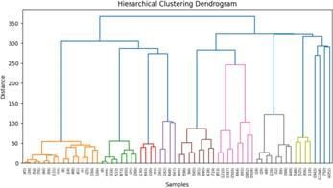

Fig. 1. Hierarchical clustering

Although effective at identifying noise and arbitrary- shaped clusters, lacked consistency with high- dimensional movie data. Similarly, the Gaussian model offered a probabilistic approach to clustering, but its computational complexity for real-time web deployment compared to the lightweight nature of K- means.

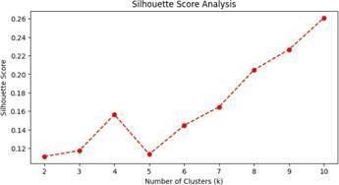

Fig. 2. Silhouette Score Analysis

To evaluate the performance of clustering, the Silhouette Score was used as a key metric. It measures how similar a data point is to its own cluster compared to other clusters, with values ranging from -1 to 1. Higher scores indicate well- defined and distinct clusters. In our system, K-means consistently achieved better silhouette scores than DBSCAN and Gaussian models, reinforcing its suitability for grouping movies based on user preferences.

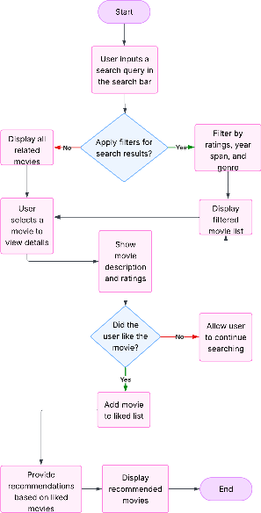

Fig. 3. Flow diagram of the working

The front-end of the system was developed using HTML, CSS, and JavaScript to ensure a visually appealing and intuitive user experience. HTML structures the layout and content of the web pages, while CSS is employed to enhance the aesthetic appeal through styling and responsive design. JavaScript is used to manage interactive elements, including input handling and asynchronous data fetching from the backend. This combination provides a fluid and engaging user experience, making it simple for users to enter preferences and receive movie recommendations in real time.

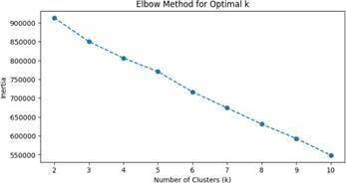

Fig. 4. Elbow Method for Optimal k

Flask, a lightweight and efficient Python web framework, was used to build the backend of the system. The Flask API acts as a communication bridge between the front-end interface and the machine learning model. User inputs collected through the interface are sent to the Flask server, where they are processed, and recommendations are generated. To enhance the richness of movie data, the system integrates with the TMDB (The Movie Database) API. This external API provides detailed metadata such as movie overviews, genres, ratings, posters, and release dates.

Table I. Score calculation for various models

|  |  |  |  |
| --- | --- | --- | --- |
| Models | Silhouette Score | CH – Score | DB – Score |
| DBScans | 0.6049 | 314.7266 | 11.6543 |
| Hierarchical | 0.3506 | 417.6793 | 10.9234 |
| K-means | 0.2695 | 751.2432 | 5.0859 |
| Gaussian Model | 0.3948 | 247.4200 | 9.6637 |

To maintain code consistency and enable collaborative development, GitHub was used as the version control platform. The project was pushed and updated regularly, ensuring that every code change was tracked, and historical revisions could be retrieved when necessary. GitHub also facilitated seamless integration with other team members and provided a robust backup of the entire project codebase.

1. Implementation Results

A clean layout was designed to allow users to input a movie title effortlessly and receive recommendations in a structured and aesthetically pleasing format. CSS was used extensively to enhance the look and feel, while JavaScript enabled interactive elements such as search bars, loading animations, and dynamic rendering of recommendation results as frontend [10]. The goal was to create an intuitive experience where users could quickly interact with the system without technical knowledge.

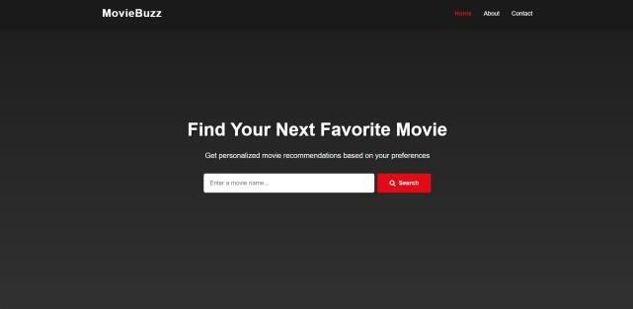Fig. 5. Home page

The backend of the system was built using Python, where the main recommendation logic was implemented. A pre-processed dataset was clustered using the K-Means algorithm based on movie overviews, allowing the system to group similar films and suggest relevant titles when queried. The backend efficiently handled requests from the frontend and returned movie suggestions by identifying the cluster associated with the searched movie. The recommendation engine, running behind Flask, ensured accurate results were generated with good response time, and unnecessary noise was

minimized through smart filtering techniques.

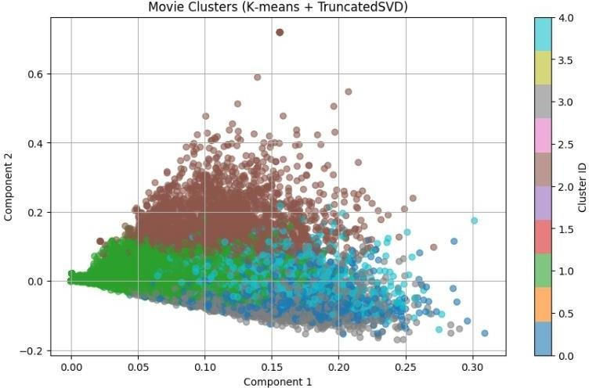

Fig. 6. Graph for K-means clustering

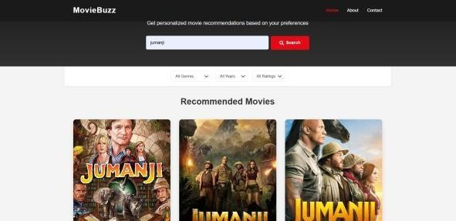

Fig. 7. Searching a movie

Fig.7. enhances the richness of recommendations, the system is integrated with The Movie Database (TMDB) API. This API fetches additional information such as poster images, genre details, release dates, and overviews for each recommended movie. As a result, users are not only provided with relevant titles but also presented with visuals and metadata that improve decision-making and content engagement. The TMDB API significantly boosts the user experience by bridging the gap between raw data and appealing presentation, making the results more immersive and interactive.

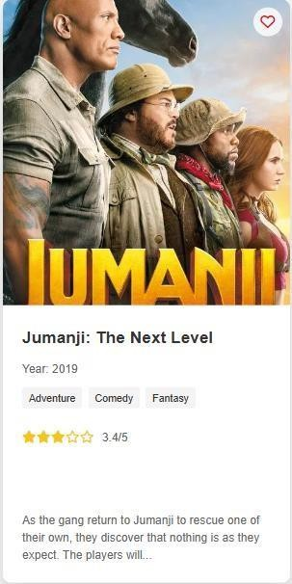

Fig. 8. Movie description and other features.

Fig.8. showcases the detailed movie card layout generated through the integrated TMDB API. It includes essential metadata such as the title, release year, genres, star rating, and a concise plot overview.

Fig. 9. Genres Dropdown

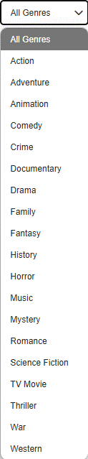Fig.9. allows users to refine their movie search based on preferred categories such as Action, Romance, or Comedy. This feature enhances the user experience by catering to individual tastes and interests. By integrating genre-based filtering, the system ensures more relevant and personalized movie suggestions.

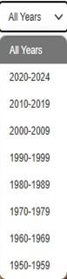

Fig. 10. Years Dropdown

Fig.9 helps users explore movies across various time periods, from classic to contemporary. This chronological browsing capability supports users in discovering films from specific eras they might be interested in. It improves the depth of exploration by offering decade-based search segmentation.

|  |  |
| --- | --- |
| Fig. 11. Ratings Dropdown  Fig.11. enables users to filter movies based on viewer ratings, such as 4+ stars or 5 stars only. This feature ensures that only well-reviewed and high-quality content is displayed, increasing user satisfaction. It also streamlines the decision- making process by prioritizing top-rated movies.  The entire system was built and tested using Visual Studio Code (VS Code), a powerful and flexible IDE that supported Python scripting, HTML/CSS/JS design, and Flask server management in one cohesive environment. Version control was handled using GitHub, which ensured smooth code backups, collaborative development, and version tracking throughout the project lifecycle. Python served as the backbone for backend logic, with additional libraries like scikit-learn and pandas assisting in data handling and clustering operations. This cohesive setup allowed for streamlined development, efficient testing, and quick debugging, leading to a robust and stable final application. | V. CONCLUSION  The development and integration of this movie recommendation system marks a significant advancement in user-centered entertainment discovery. By combining a dynamic front end with robust backend functionality, and leveraging APIs like TMDB and Flask, the system delivers accurate, visually rich, and personalized movie suggestions. Its ability to search based on genre, release year, and viewer ratings not only enhances relevance but also caters to a wide spectrum of user preferences. The visual appeal, supported by metadata such as posters, ratings, and descriptions, transforms raw data into engaging content, elevating the overall user experience.  Moreover, the seamless interaction between the interface and data sources reflects the system’s technical soundness and practical viability. Deployed successfully using HTML, CSS, JavaScript, Python, and Flask on platforms like Visual Studio Code and GitHub, this project demonstrates both functionality and scalability. The results affirm that the system meets its core objectives—reliability, accuracy, and user engagement—while also setting the foundation for future enhancements, such as sentiment analysis or collaborative filtering. In essence, the project exemplifies the fusion of intuitive design and intelligent technology, offering users a powerful tool for discovering and enjoying movies effortlessly.  This project not only showcases technical proficiency but also addresses real-world needs in the entertainment domain. By streamlining the process of movie selection through intelligent filtering and interactive design, it bridges the gap between data-driven insights and user satisfaction. With its successful deployment and functional accuracy, this system stands as a valuable contribution to modern recommendation  technologies and holds great potential integration into larger platforms or mobile applications |

References

1. Adomavicius, G., & Tuzhilin, A. (2005). Toward the next generation of recommender systems: A survey of the state-of- the-art and possible extensions. IEEE Transactions on Knowledge and Data Engineering, 17(6), 734–749.
2. Bobadilla. J, Ortega. F, Hernando. A, & Gutiérrez. A. (2013). Recommender systems survey*.* Knowledge-Based Systems, 46, 109–132.
3. Tan, K.L., Lee, C.P., & Lim, K.M.(2023). “A Survey of

Sentiment Analysis: Approaches, Datasets, and Future Research. Applied Sciences”, 13(7), 4550.

1. Zhang, Y., & Chen, X. (2020). Explainable Recommendation: A Survey and New Perspectives. Foundations and Trends® in Information Retrieval, 14(1), 1–101
2. Varma, A. N., & Petluri, K. (2021). Movie Recommender System using Critic Consensus. arXiv preprint arXiv:2112.11854.
3. Zhang, S., Yao, L., Sun, A., & Tay, Y. (2019). Deep learning based recommender system: A survey and new perspectives. ACM Computing Surveys (CSUR), 52(1), 1–38
4. Jain, A. K. (2010). Data clustering: 50 years beyond K-means. Pattern Recognition Letters, 31(8), 651–666.
5. Xu, R., & Wunsch, D. (2005). Survey of clustering algorithms. IEEE Transactions on Neural Networks, 16(3), 645–678.
6. Ghelichi, R., & Fallah, M. (2020). Movie recommendation system based on clustering and collaborative filtering. Journal of AI and Data Mining, 8(1), 85–94.
7. Li, J., Chen, H., & Sun, X. (2022). A scalable and efficient K- means approach for large-scale movie recommendation*.* Expert Systems with Applications, 198, 116871
8. Wang, Y., Yu, H., & Fesenmaier, D. R. (2002). Defining the virtual tourist experience*.* Annals of Tourism Research, 29(4), 999–1005.
9. Zhou, Y., & Sun, Y. (2022). Improving movie recommendation systems through enriched metadata via external APIs. Journal of Web Engineering, 21(5), 1571–1590.
10. Rodriguez, A., & Nguyen, T. (2021). Enhancing recommendation systems with API-driven data visualization. International Journal of Computer Applications, 183(24), 35–42.
11. Grinberg, M. (2018). Flask Web Development: Developing Web Applications with Python. O’Reilly Media.
12. Kumar, R., & Singh, A. (2021). Design and implementation of a dynamic movie recommendation web application using Flask and REST APIs. International Journal of Advanced Computer Science and Applications, 12(9), 612–618.